Name: _______________________________

Document Analysis Organizer
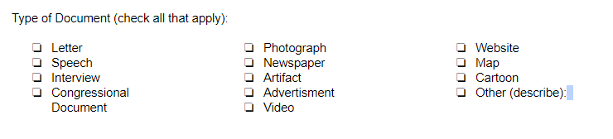
Is the source primary or secondary? Circle one.  Who wrote the source?  When was the source created?  What is the purpose of the source?  Who is the intended audience?  Sec. Source Info (website URL, publisher, etc) | Identify any source biases.  Is the source reliable? Why or why not?
What is happening at the time in history when the source was created?

What is the evidence from the source that will help you with your project? | In what ways does this source agree/disagree with other sources/evidence you found?

Name: _______________________________

Document Analysis Organizer
About the Source | Reliability
Contextualization

Evidence | Corroboration

